2026 - 27 Alliance Selection Script
Event Portal Automation:
- This script is provided for reference, but events are strongly encouraged to use the built-in event portal script automation.
- The event portal will auto-populate known information and guide the Emcee through the Alliance Selection based on event size and format.
- This script is available when logged into the Emcee role in the event portal.
- Emcees should open the “Alliance Selection” page on a tablet logged into the event portal and run the ceremony without additional support from field staff. When Emcees select a team number on the page, they will be provided with the team’s name and prompted to indicate whether the team accepts or declines the invitation. Input from the Emcee will be reflected on the audience display.

Video Assets:
- NEW for 2026-27: Alliance Selection Audience Explainer videos are built into the event portal and are mandatory at English-language events! If your event language is not English, reach out to FIRST® Tech Challenge Support and/or Global Key Production for the video script to translate to your event’s language, for your Emcee to deliver.
  - This video runs before the Emcee takes the stage and replaces most of the content Emcees used to give explaining the Alliance Selection process to the audience. The Emcee now focuses on interviewing the students for their selections.
- Available for download from Box file sharing service (public access).
- Available for download within FTC Live (FTC Live Setup Guide)

Important Notes:
- The alliance selection is an important part of the FIRST® Tech Challenge event for both teams and the audience and should be presented as scripted.
  - While Emcees are encouraged to make notecards for ceremonies and perform components of ceremonies in their own words, underlined portions of the dialogue below should be presented exactly as scripted.
- Each division selection can be done as a combined ceremony or two parallel events. One division should not have measurably more time between alliance selection, and the beginning of playoff matches.
- The number of alliances formed is based on the number of teams included in the Qualification Schedule. Details on the alliance selection process are available in the Competition Manual, in section 13.7.1.

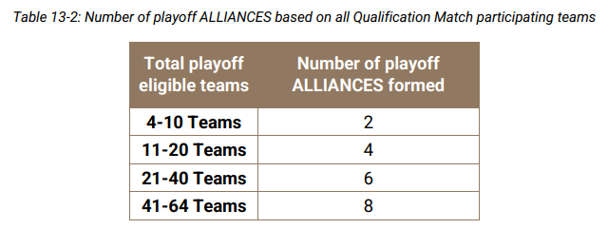

- Before beginning alliance selection, determine where each Alliance will stand:
  - Place a visual indicator on the Arena floor to indicate where representatives will stand. If your event is using captain armbands, use those. Other options include scoring elements or gaffers tape spike marks.
  - From the audience perspective, the highest-ranked alliance should be furthest left, and the lowest-ranked alliance furthest right.
  - When spacing the indicators, plan accordingly for 4 students per alliance to share the physical space.
  - If your event is streaming, verify that indicator locations are visible to the stream camera as desired.
  - Verify indicator locations with FTA and AV team
  - A suggested layout for a 6-alliance selection is below, modify for your event as needed:

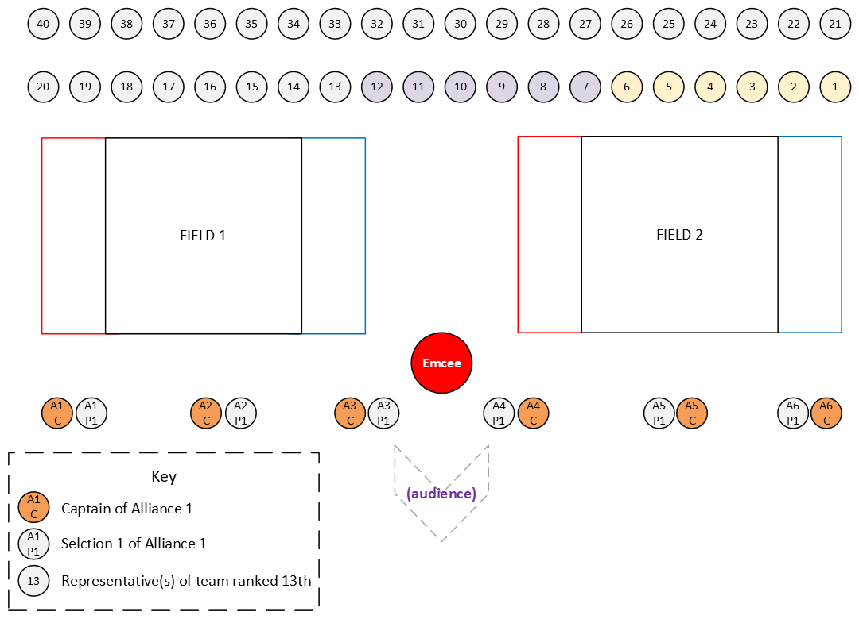

- Prior to alliance selection, an Emcee or Game Announcer should work with Queueing volunteers to verify the presence of student representatives.
  - We recommend printing the Team Placards Report, sorted by rank, from the event portal to create sheets for each team to hold or stand on while staging for Alliance Selection.
  - NEW for 2026-27: Up to two student representatives are allowed per team!
  - As part of the alliance selection ceremony, many events queue student representatives in one location, then have them walk into the Arena to be celebrated by the audience, led by a Queuer, Game Announcer, or additional Emcee. Rehearse the desired flow with Queueing volunteers and FTA prior to Alliance Selection.
- Verify with Head Referee where they would like to meet with Alliance representatives and when Playoff Matches will begin before you start alliance selection.

Key:
[Green Highlight] – If using the scoring system script feature, data will automatically be filled in
[Yellow Highlight] – User must fill-in data based on their event information
(Action) – Indicates an action or non-verbal interaction
(Blue Highlight) – This indicates a transition from between Ceremony and Matches

Event Type | Speaker | Dialogue | Blocking Notes
 |  | (Play ~2-minute Alliance Selection Explainer Video for Event Size from Scoring System)
All | Emcee | WOW what a great day of qualification matches so far!  It’s now time to move onto the playoff portion of the competition!  But first, with [Insert number of teams] competing today, we need to form the [2/4/6/8 from Table 13-2 in the Competition Manual] alliances that will compete to become the BIOBUZZ presented by RTX winners, here at the [Insert name of Event]. | The Emcee runs the alliance selection in the Arena.
 | Emcee | Teams who advance from this event will receive an invitation to [Insert next level of Tournament play]  This event will advance a minimum of [insert number] of teams to the next event. | Your Program Delivery Partner must confirm the number of teams advancing from this event and to where.
 | Emcee | There’s a lot on the line here. Let’s meet the teams!
 |  | Make it loud for all [number of teams competing] here at [event name]! | Only if walking queued team representatives into the Arena prior to selection  Student representatives move from queuing location to Arena.
 | Emcee | Teams, please join me if you hear your team number and name called. | Emcee moves to location where Alliance 1 will stand
 | Emcee | First, our number one ranked team with a record of [team’s record] after [number of qualification matches], congratulations to team # [Insert Team # and name]. | Number one seed will stand next to the Emcee.
 | Emcee | The Captain of our Number One Alliance will make the first pick. Which team would you like to invite to join your alliance?  [Selected Team # and Name], please join us in front of the field(s).  (If team is not in top 2/4/6/8 unselected teams) Do you accept this invitation to form an alliance?  (If team is in the top 2/4/6/8 unselected teams) Do you accept or would you prefer to form your own alliance?  (If team declines) That’s okay! While [team number] is ineligible for future selection, we’ll have them head back to our pool of student representatives, and we’ll ask [Alliance One Lead Team #] to make another selection.  Congratulations! We now have Alliance One for our playoff tournament! | Teams respond with something like:  “Team #xxxx would like to invite team #xxxx to be our alliance partner.”  Emcee taps selected team in scoring system tablet and reads team’s number and name when prompted.  The invited team representative(s) will join the Emcee and Alliance One representatives  Team responds with something like:  “Team #xxxx declines”  Emcee maintains a positive attitude toward declining teams  Continue until a selected team accepts.  Team responds with something like:  “Team #xxxx accepts”
 | Emcee | Congratulations! Now we’ll move to the next Alliance Captain! Please welcome the representatives from our next highest-ranked team, [Team # and name]  Which team would you like to invite to join your alliance? | Repeat until all but the last Alliance Lead has a Partner.  STOP before you complete the last selection to complete the alliances.
 | Emcee | Before we learn who the last Alliance Captain’s invitation will be, one last note.  Once we have finalized our Alliances, the Head Referee will meet with all the alliance representatives [verify location of meeting with your Head Referee] to cover the rules of the playoffs.  If your team is an Alliance Lead and you plan to have a different student who is on your drive team serve as your Alliance Captain during playoffs, we will ask that you have that person ready to send down to the field immediately following alliance selection.  For all of our teams, again, congratulations on your work this season. While only a portion of our teams will be playing matches in the Playoffs, please remember that we’ll be presenting awards between the playoff rounds and we’d love to hear all of you choose an Alliance to cheer on throughout the rest of our event.
 | Emcee | Team [insert team number] which team would you like to invite to join your alliance? | Continue accept/decline process above
 | Emcee | What an exciting tournament it’s going to be! Let’s hear a big round of applause for all the teams competing today.  At this time, Alliance Representatives will meet with the Head Referee at [Insert Location] to review our tournament rules.  We’ll give the alliances some time to talk strategy and prepare for the playoff matches, which will begin at [Insert Time].  Remember, awards will be presented during the playoffs—so stick around, cheer loud, and we’ll see you back here soon! | Beginning of playoff time set by scorekeeper before alliance selections starts, can be adjusted immediately following selection process if needed.

